**Our Festive Thanks**



It's almost Christmas -

it's time to pause,

while we open

and close some doors.

Time to think how our actions

so often quite unseen,

decide where we are heading,

reminding us where we've been.

At times without thinking,

we claim victories as our own -

we sometimes think we've created the flower,

when it's only the seed we've sown.

We progress through life

so often in haste -

we drink the wine

without tasting the taste.

Life can be a bit like a puzzle -

pieces floating about in space,

but nothing can ever be achieved

until those pieces are put in place.

It's almost Christmas -

so let us pause for a while ......

regardless of the mixed year it's been,

just break into a smile !

Those of you who made our year a good one -

those of you, we're fortunate to know,

we wish you a happy, healthy Christmas -

and thank you all for helping us grow !



*Ron Manners*

*Dec. 2012*

[*www.mannkal.org*](http://www.mannkal.org)

2012 - 2013

**Mannwest Group & Mannkal Foundation**

Hayek on Hood

Unit 3 / 31 Hood Street

Subiaco (Perth) Western Australia, 6008

Tel: +6 8 9382 1288

Mobile: 0419 312 222

**Email:** [**mannwest@mannkal.org**](mailto:mannwest@mannkal.org)

[ron.manners@mannkal.org](mailto:ron.manners@mannkal.org)

Websites: [www.mannwest.org](http://www.mannwest.org)

[www.mannkal.org](http://www.mannkal.org)

[www.HeroicMisadventures.com](http://www.HeroicMisadventures.com)

**Mannkal’s Musings - 15th Anniversary edition:**

<http://alturl.com/b2325>

* Facebook:

Ron Manners –

facebook.com/ron.manners

Mannkal –

facebook.com/Mannkal

* **New book** of romantic poetry due for release 2013.
* For information on **current books**:

*Heroic Misadventures*  -

[*www*.HeroicMisadventures.com](http://www.HeroicMisadventures.com)

*Never A Dull Moment –*

[*http://www.mannwest.com/bookshop.php*](http://www.mannwest.com/bookshop.php)

* *Do you know of any young Western Australians who may be eligible for a Mannkal Scholarship? If so go to our website:-*

[*http://www.mannkal.org/scholars.php*](http://www.mannkal.org/scholars.php)

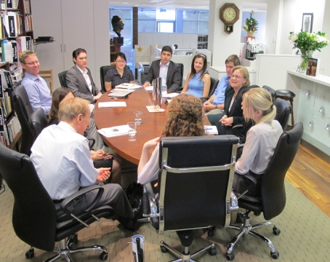

U.S. Consul General Aleisha Woodward, meets with Mannkal’s 2012/13 outbound international interns.